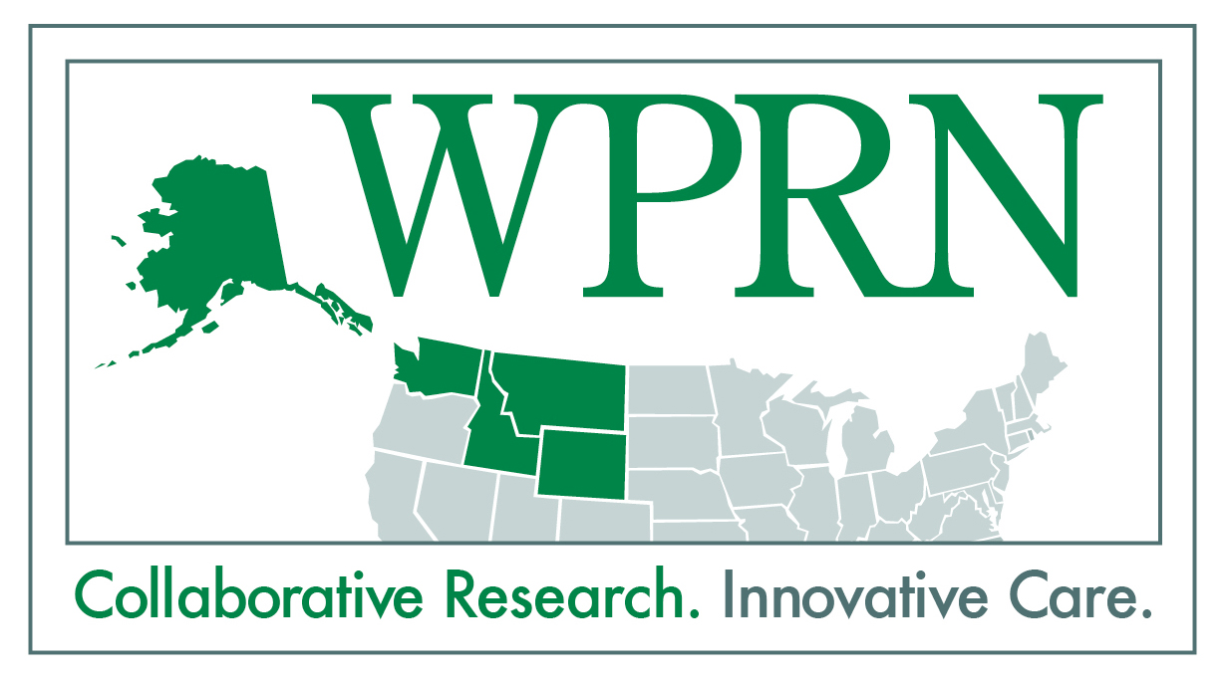
Patient Preferences for Weight Loss Programs

What is the “Patient Preferences for Weight Loss Programs” study? “Patient Preferences for Weight Loss Programs” is a WWAMI region Practice and Research Network (WPRN) card study that is supported by the Institute of Translational Health Sciences at the University of Washington. A card study is a method of efficiently gathering information about patients and patient care, at the point-of-care. This type of observational study can be used to describe clinical problems, patterns of disease, and practice patterns, among others. A card study is essentially a very short survey that usually takes a minute or less to complete, and is typically anonymous. Card study data can be collected either from providers when they see patients, or from patients when they come for a visit.
What’s the purpose of the “Patient Preferences for Weight Loss Programs” study? We want to know how likely patients are to take part in a comprehensive weight loss program, like ones recommended by the US Preventive Services Task Force (USPSTF). We also want to learn about what factors influence patients’ decisions to participate (or not) in a program like this.
Why is this important? Being overweight can increase people’s risk of many health problems, including heart disease and diabetes, and the prevalence of obesity is increasing. Recently, the United States Preventive Services Task Force (USPSTF) recommended that clinicians offer or refer obese adult patients to intensive, multicomponent, behavioral interventions for weight loss. This study will help researchers and clinicians understand whether or not primary care patients will participate in these types of programs and understand the factors that influence participation.
How will the study work? If your clinic decides to take part, clinic staff (most likely at the front desk) will ask every patient who checks in for a visit and is over 18 years old to complete a short survey. Patients will be directed to drop the survey in a collection box in the clinic waiting room. The data collection will occur over a 1-4 week period. Your clinic’s research champion (or someone designated by the champion) will collect the completed surveys and return them to the WPRN Coordinating Center at the University of Washington in Seattle, WA. Since the study is low risk and the survey is anonymous, the University of Washington does not require human subjects review.
How will providers, the clinic, and staff be affected? The card study survey will be anonymous, so providers, nurses and staff will not see patients’ responses. Providers will continue to treat overweight and obese patients as they normally would. Front desk staff will need to ask patients to fill out the survey and answer questions about how to return it during a 1-4 week data collection period.
How will our clinic benefit from participating? Your clinic’s participation will allow primary care providers to better understand if primary care patients would participate in comprehensive weight loss programs and what factors influence their participation. Your clinic will receive a report of the research findings once the study is completed. Gathering this information will also help WPRN practices, researchers, and other collaborators to apply for a federal grant about weight loss management and treatment.
When would this study occur? The WPRN Coordinating Center is currently recruiting practices to take part. We hope to have all data collected by the end of June 2013.
How can I get more information? If you would like to find out more about the study, or would like to sign up to participate, please contact Gina Keppel (gakeppel@uw.edu, 206-685-0750) or Dr. Allison Cole (acole2@uw.edu, 206-543-8906).

